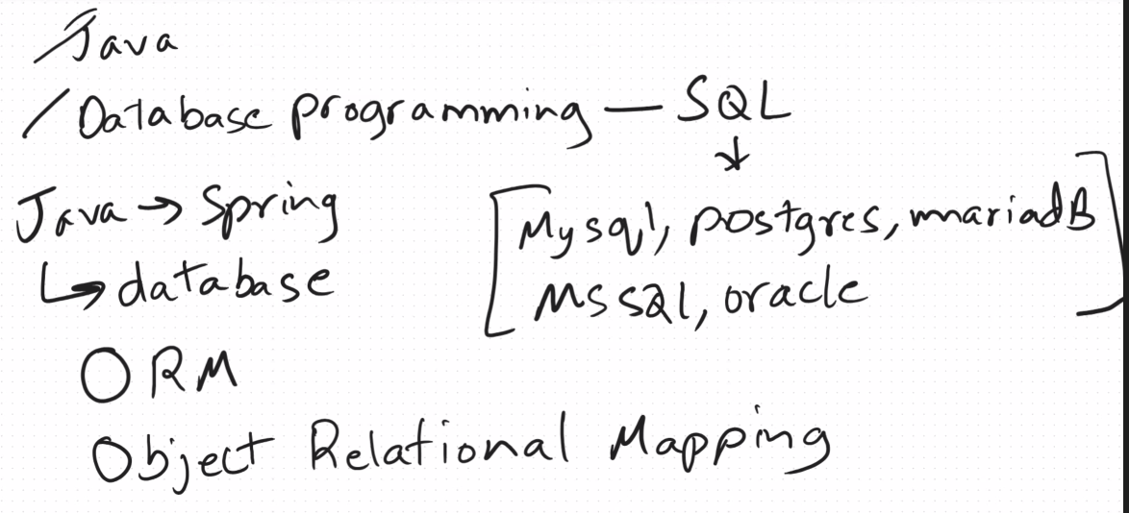



Using java how can I access the database that’s called the ORM tool.

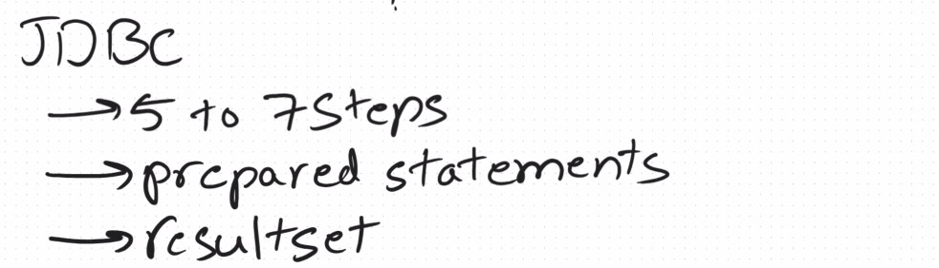

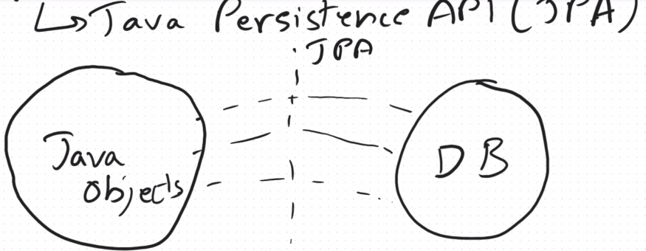

These specifications are provided by the hibernate

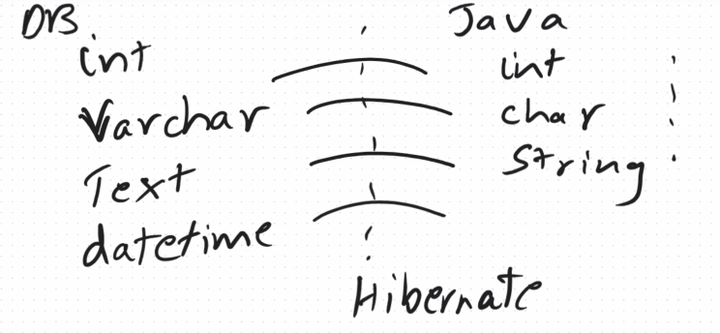

Hibernate ORM link

<https://docs.jboss.org/hibernate/orm/6.6/userguide/html_single/Hibernate_User_Guide.html>

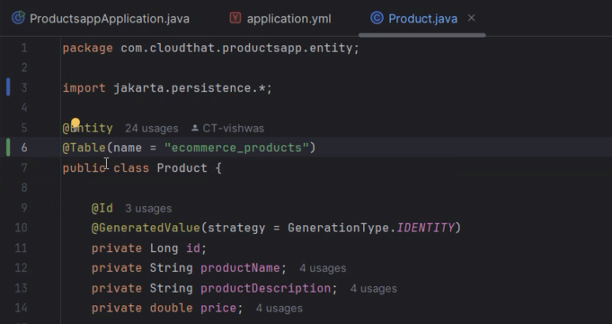

@Table(name=”ecom…”) is used to change the table name.

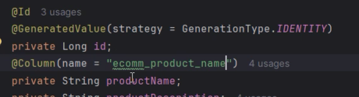

@Coolumn(name = “ecom_product_name”) is used to change the column name.

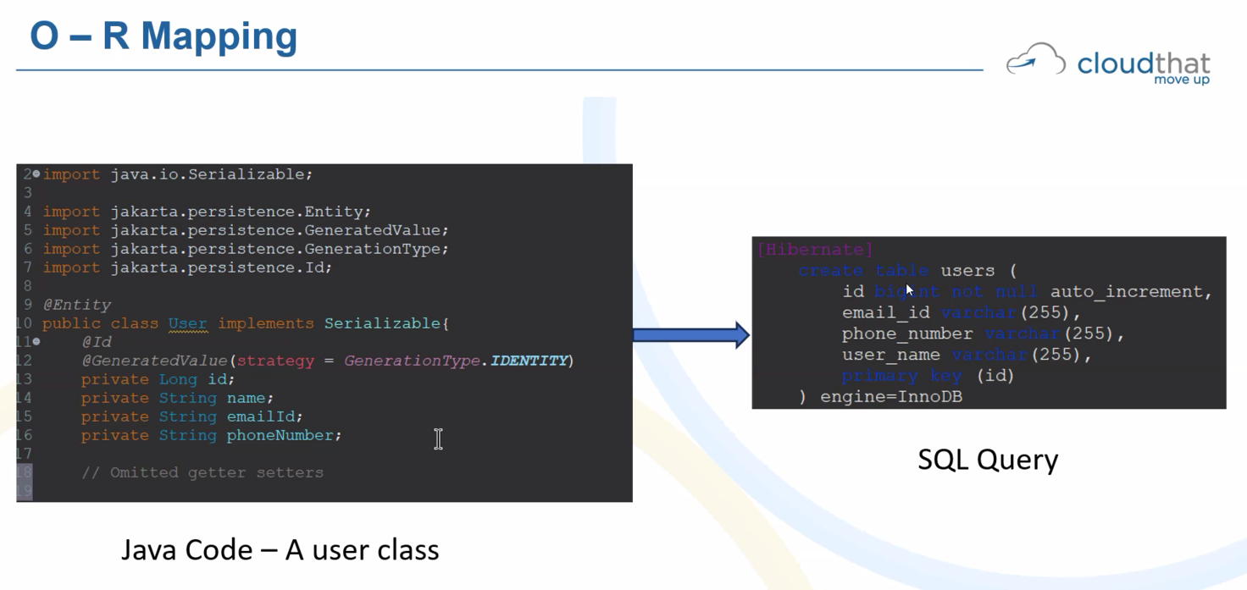

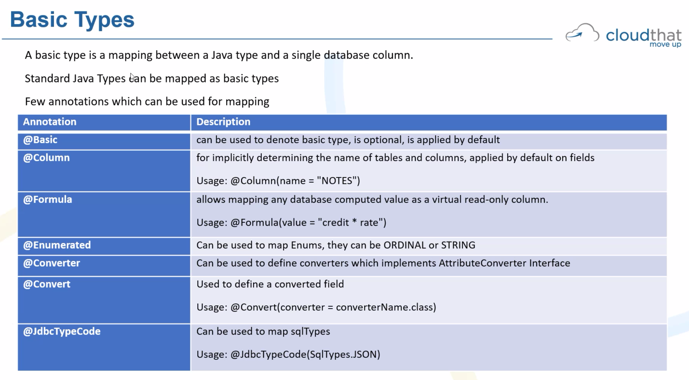

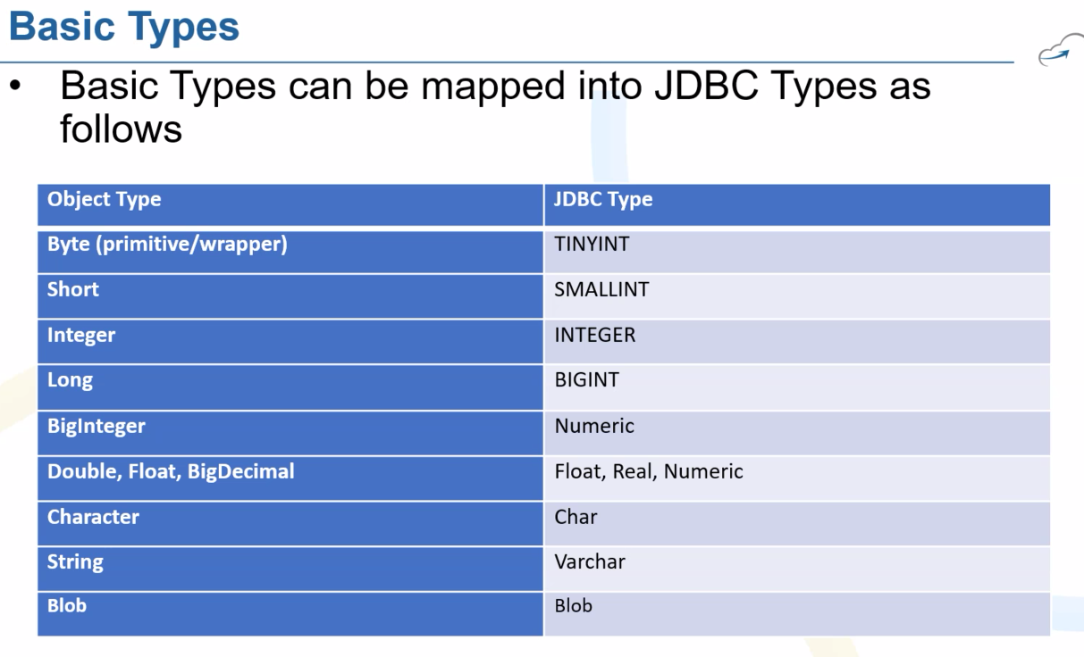

Ordinal value

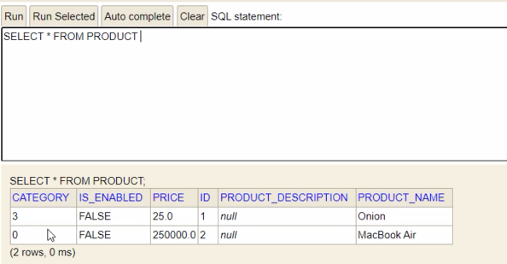



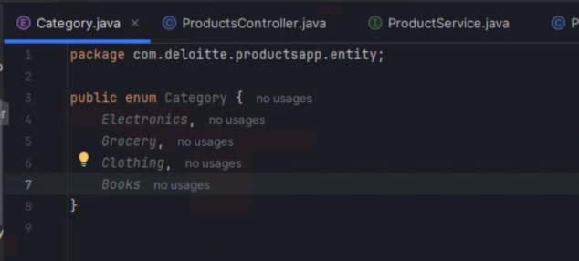

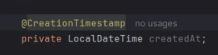

Generate getter and setter,

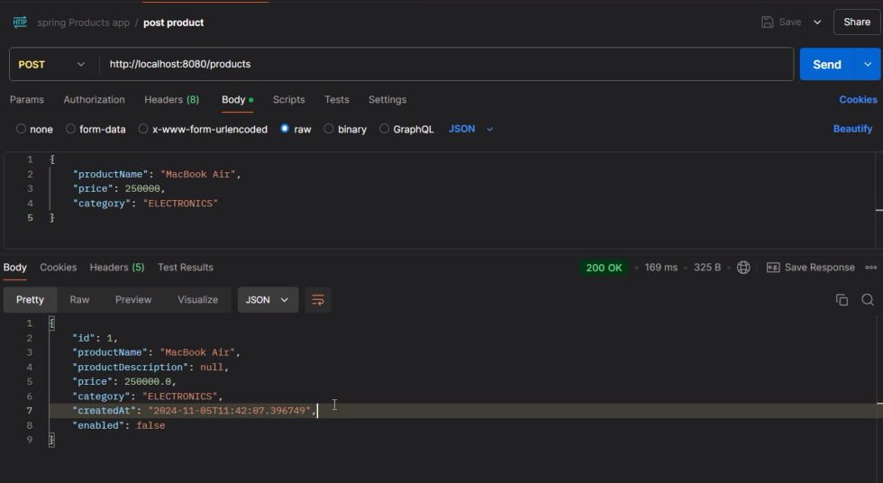

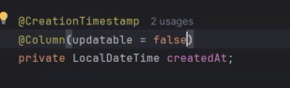

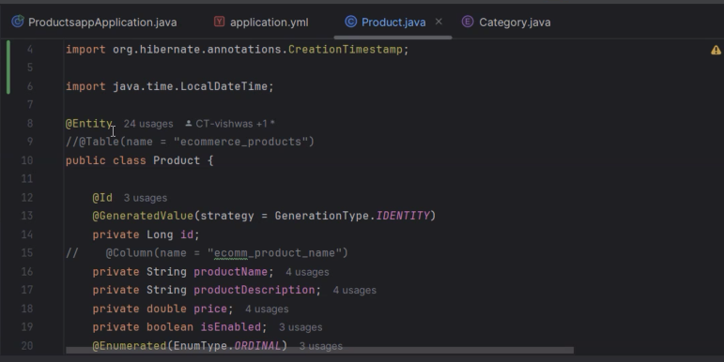

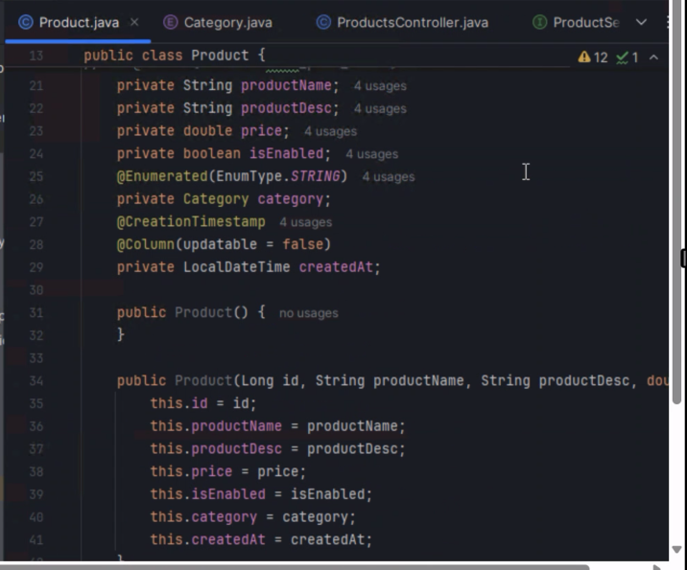

Create a new embedded entity names properties.java (‘embedded properties’ not sure about the quotes check cgpt instead of primivite data types)

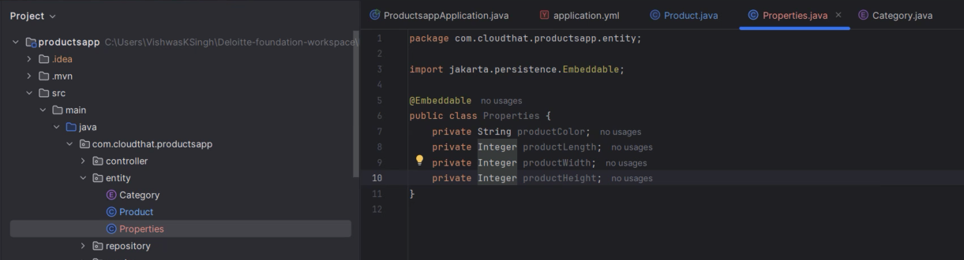

And generate getter and setters and constructor with all arguments and no argument.

Rename it as Product Properties

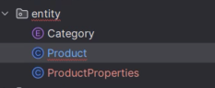

In product.java

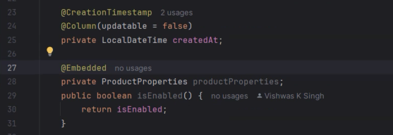

Add the embedded code on line 27 and 28.

O/P

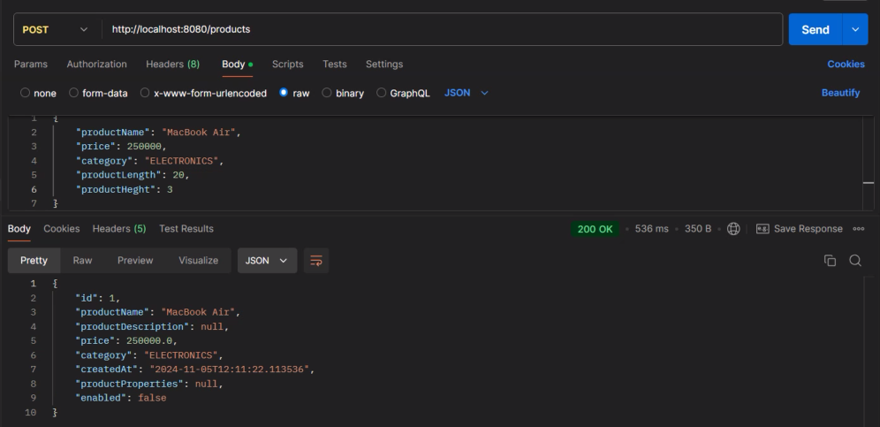

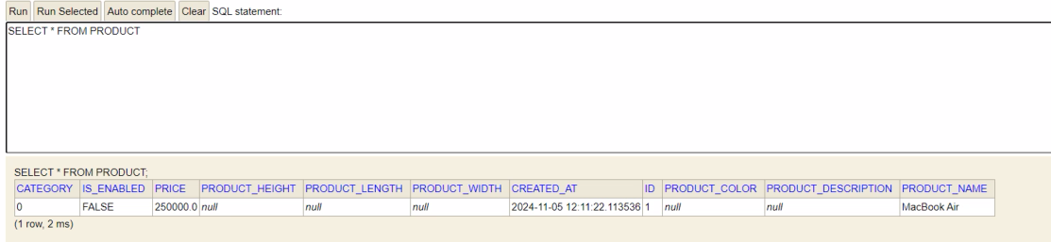

But we didn’t get that here so we need to add the product properties.

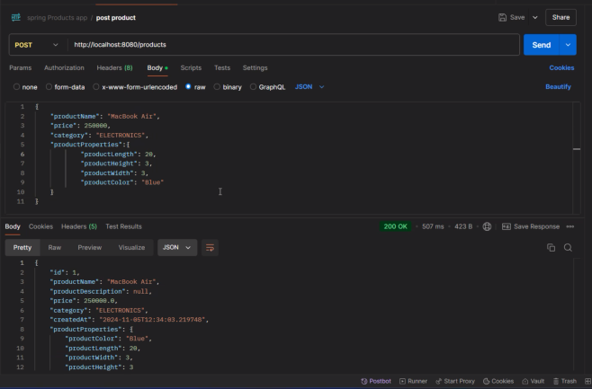

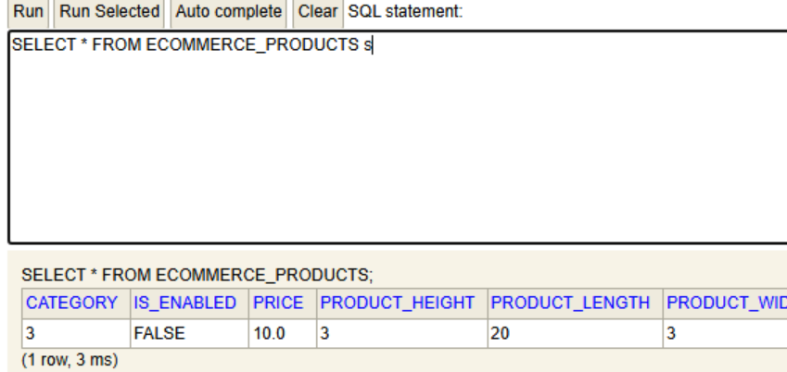

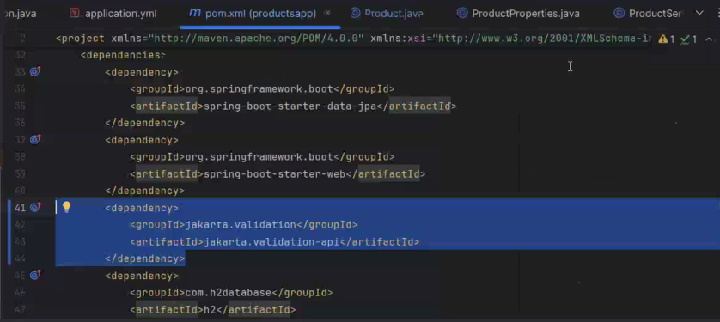

In pom.xml add these Jakarta validation so that @NotBlank and other operations can be performed which is in below image.

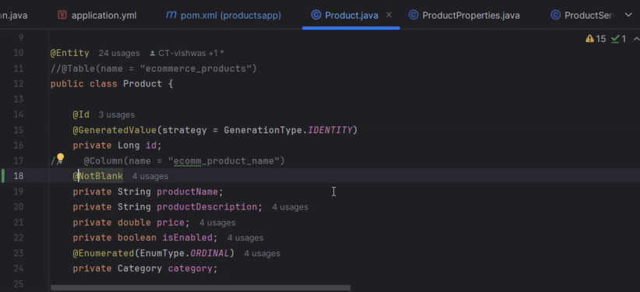

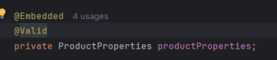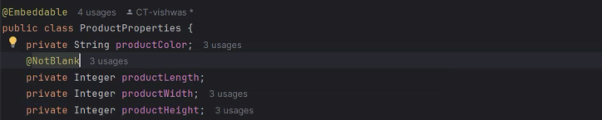

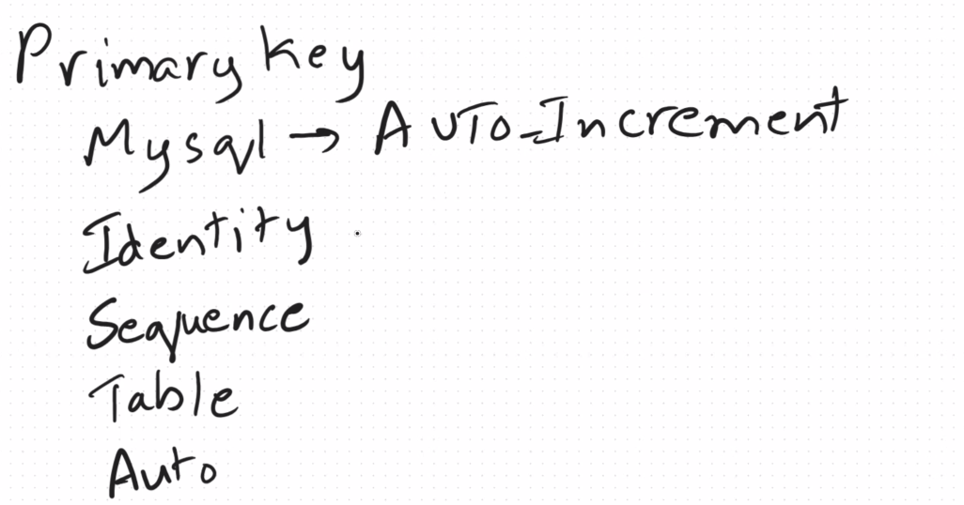

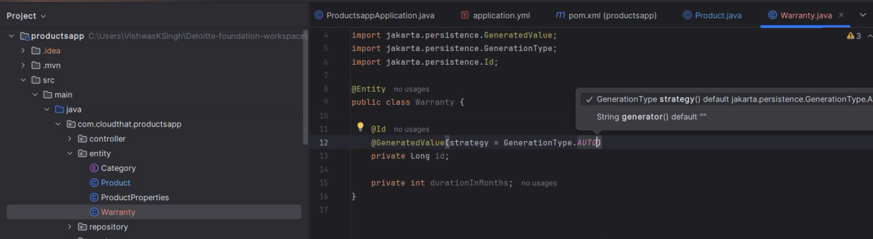

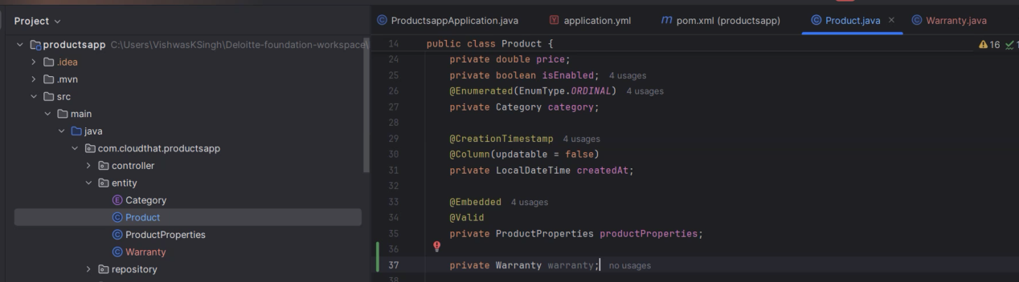

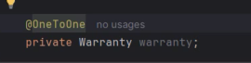

What should happen if I delete a product so for that we are adding CascadeType. One product should have one Warrenty

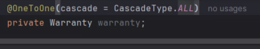

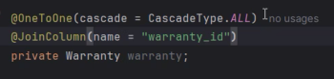

In product.java add this warranty (getters, setters and no/all argument constructors, toString)

Do the same in warranty.java entity also.

Create another entity shipper

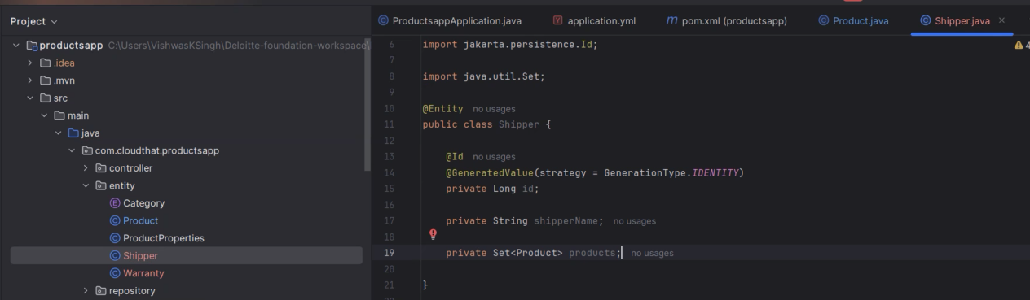

And in product.java class map this shipper entity.

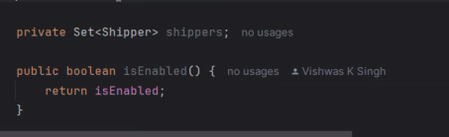

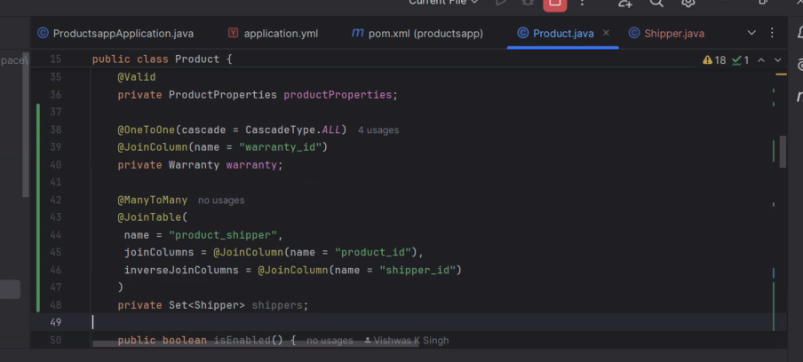

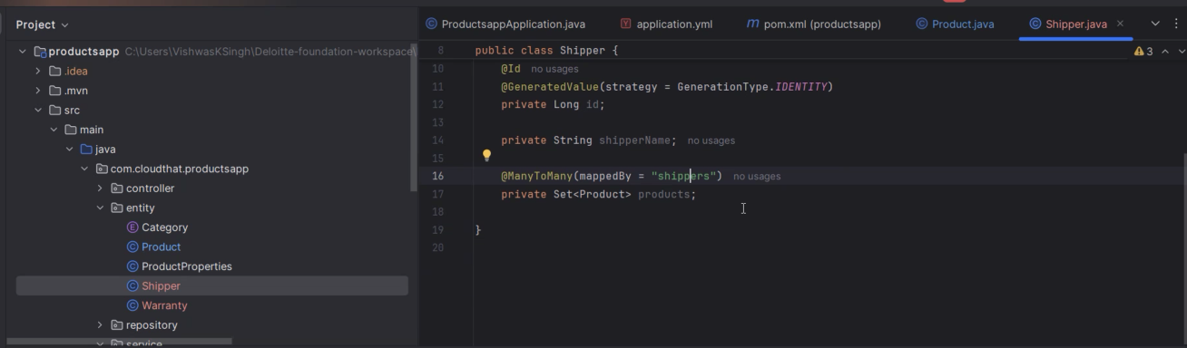

Hibernate ORM User Guide

<https://docs.jboss.org/hibernate/orm/6.6/userguide/html_single/Hibernate_User_Guide.html#associations>

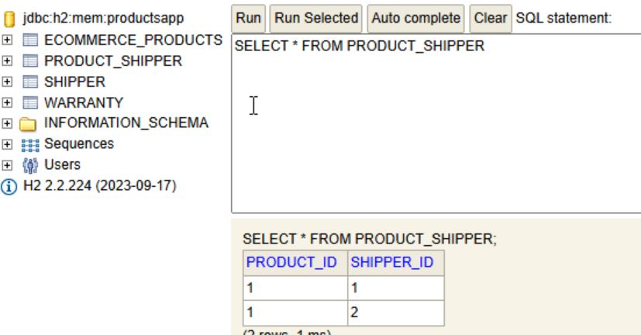

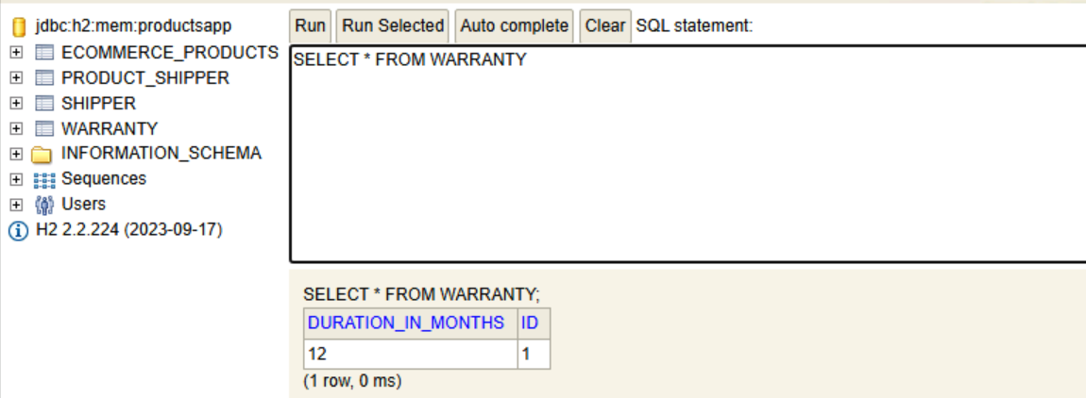

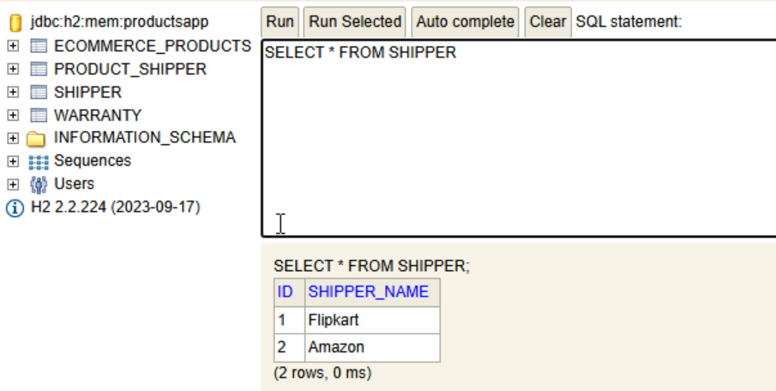

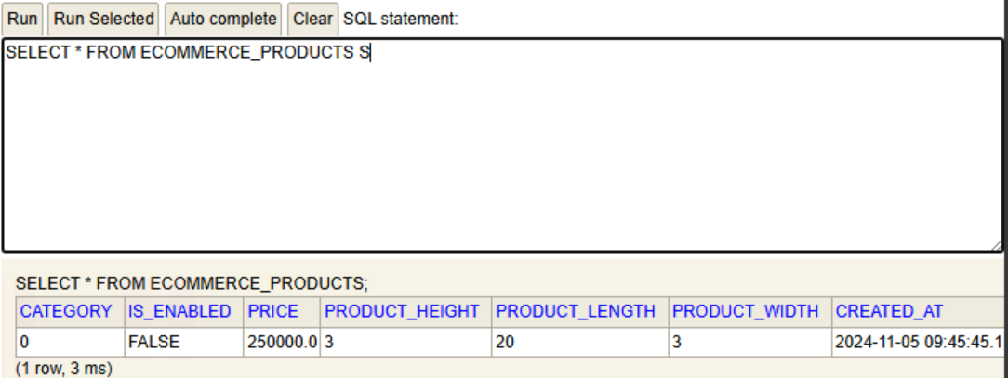

Whenever u see noun or entity you have to create separate end points for it.

Link for Cascade types

<https://docs.jboss.org/hibernate/orm/6.6/userguide/html_single/Hibernate_User_Guide.html#pc-cascade>

Switching from hibernate to mysql :

Add dependency in pom.xml file

And add these in application.yml file

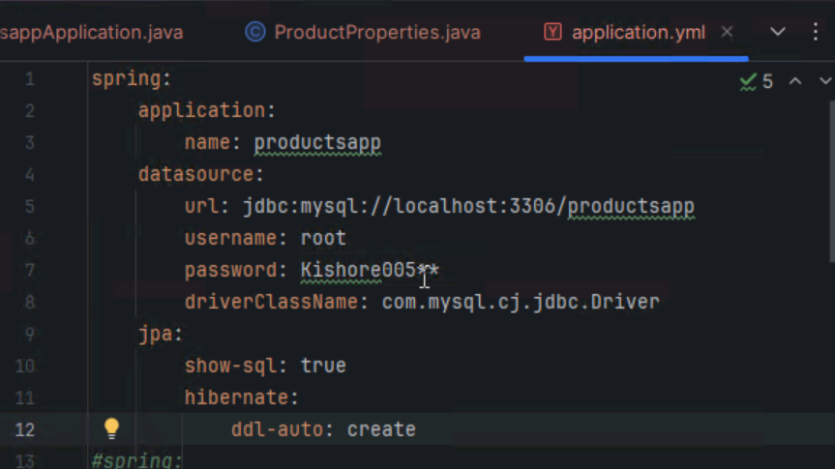

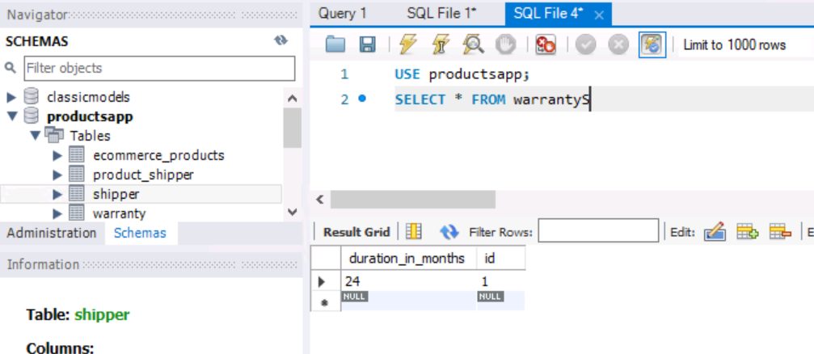

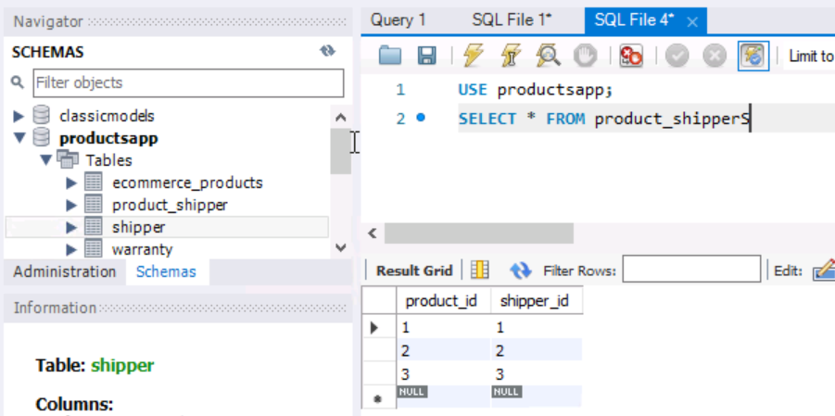

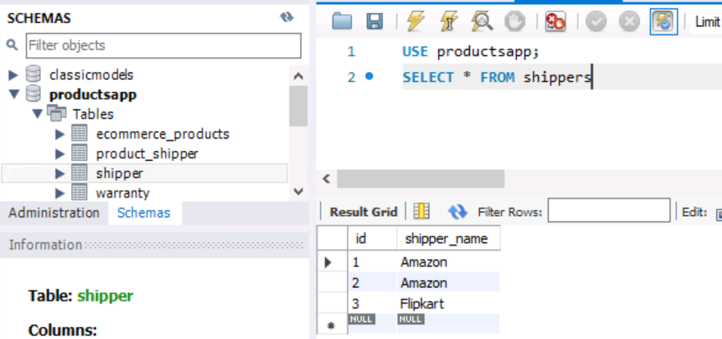

<https://docs.spring.io/spring-data/jpa/docs/1.5.0.RELEASE/reference/html/jpa.repositories.html>

get productbyName

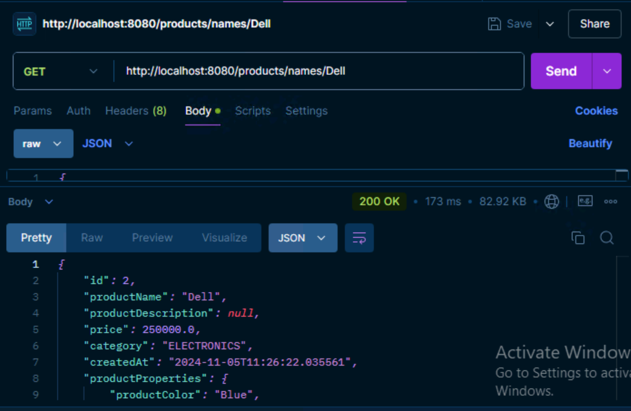

Create a package model and inside it create a java class ApiResponse